

ASSIGNMENT-3

# PYTHON

# **NAME : MADA SRAGVIN KUMAR**

# **MIS NO : 112315097**

# **GROUP : 3**

**YEAR : 2**

**SECTION : A**

# **1.c**

a=input("enter the string: ")

d={}

c=[]

for i in a:

if i.isalpha:

if i not in c:

d.update({i:a.count(i)})

c.append(i)

print(d)

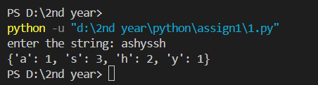

# **2.c**

a=input("enter the string: ")

l=a.split()

print(l)

s="#".join(l)

print(s)

b=input("enter the date of birth in this format(dd/mm/yy): ")

d={}

k=b.split("/")

d.update({"date":k[0]})

d.update({"month":k[1]})

d.update({"year":k[2]})

print(d)

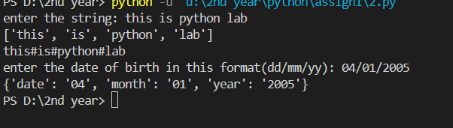

# **3.c**

def gcd(a,b):

if a<b:

if b%a==0:

return a

else:

return gcd(a,b%a)

else:

if a%b==0:

return b

else:

return gcd(a%b,b)

def lcm(a,b):

return (a*b/gcd(a,b))

a=int(input("enter the number 1: "))

b=int(input("enter the number 2: "))

c=gcd(a,b)

d=lcm(a,b)

print(c)

print(d)

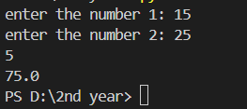

# **4.c**

from math import sqrt

def ball_collide(a1,a2):

if sqrt(((a2[0]-a1[0])*2+(a2[1]-a1[1])*2)<=a1[0]+a2[0]):

return True

else:

return False

x1,y1,r1=int(input("Enter the x-coordinte of ball1: ")),int(input("Enter the y-coordinte of ball1: ")),int(input("Enter the radiusof ball1: "))

x2,y2,r2=int(input("Enter the x-coordinte of ball2: ")),int(input("Enter the y-coordinte of ball2: ")),int(input("Enter the radius of ball2: "))

a=ball_collide((x1,y1,r1),(x2,y2,r2))

if(a==True):

print("The two balls will collide")

else:

print("The two balls will not collide")

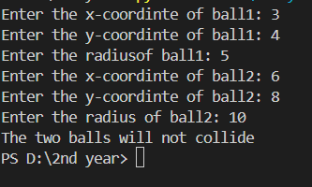

# **5.c**

a=[1,6,3,9,2,56734,539,6,]

b=[]

max=[]

sum=0

for i in range(0,len(a)):

sum=sum+a[i]

print(f"The mean of the numbers is {sum/len(a)}")

for i in a:

if i not in b:

max.append(a.count(i))

b.append(i)

max.sort(reverse=True)

for j in a:

if j not in b:

b.append(j)

for j in b:

if max[0]==a.count(j):

print(f"The mode of these numbers is {j}")

a.sort()

if(len(a)%2==0):

print(f"The median of these numbers are {a[len(a)//2-1]+a[len(a)//2]}")

else:

print(f"The median of these numbers are {a[len(a)//2]}")

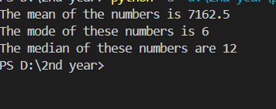

# **6.a**

# **Bubble sort**

def buble_sort(a,n):

for k in range(0,n):

ptr=0

while ptr<n-k-1:

if a[ptr]>a[ptr+1]:

t=a[ptr]

a[ptr]=a[ptr+1]

a[ptr+1]=t

ptr+=1

a=[1,6,3,9,2,7,5]

buble_sort(a,len(a))

print(a)

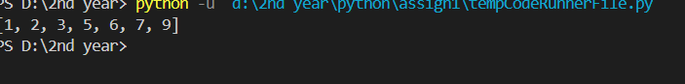

I will do later

Sorry for the late submission